
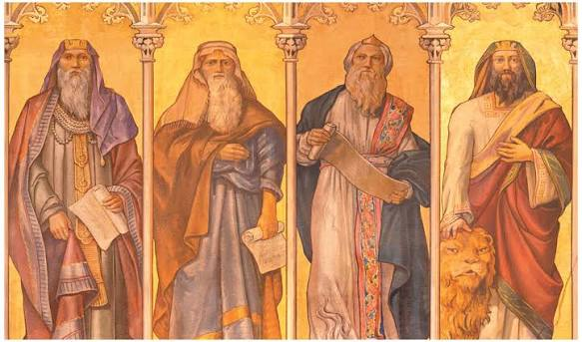
H
Fourth Sunday of Advent: Glory be to God who will keep you according to the good news that has already been revealed

Compare to Romans 1:1-3, 6, 11 “From Paul, a slave of Christ Jesus, called to be an apostle and set apart for God’s good news (εὐαγγέλιον). God promised this good news about his Son ahead of time through his prophets in the holy scriptures… Through him we have received God’s grace and our appointment to be apostles. This was to bring all Gentiles to faithful obedience (ὑπακοὴν πίστεως) for his name’s sake. You who are called by Jesus Christ are also included among these Gentiles…I really want to see you to pass along some spiritual gift to you so that you can be strengthened.”

ᾧ ἡ δόξα εἰς τοὺς αἰῶνας·
doxa
These verses may not belong here and may not have been written by Paul. Some ancient manuscripts have these verses at the end of Romans 14. One has it at the end of Romans 15. Several include it here. (More on this later.)
²⁵ May the glory be to God who can strengthen you with my good news and the message that I preach about Jesus Christ. He can strengthen you with the announcement of the secret that was kept quiet for a long time. ²⁶ Now that secret is revealed through what the prophets wrote. It is made known to the Gentiles in order to lead to their faithful obedience based on the command of the eternal God. ²⁷ May the glory be to God, who alone is wise! May the glory be to him through Jesus Christ forever! Amen.
Romans 16:25-27
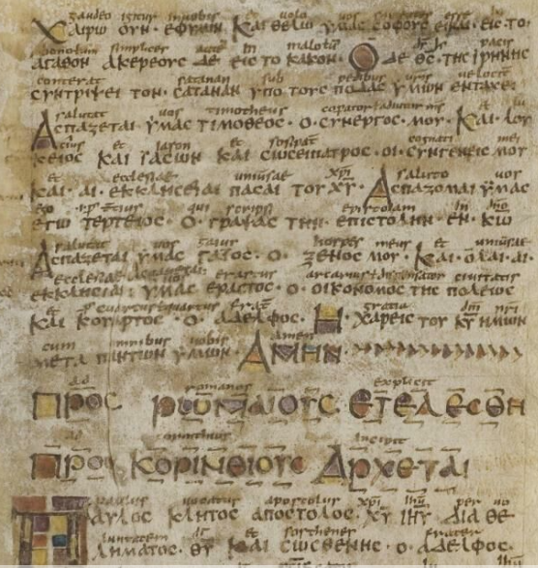
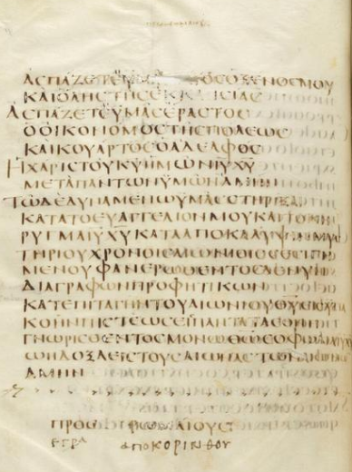
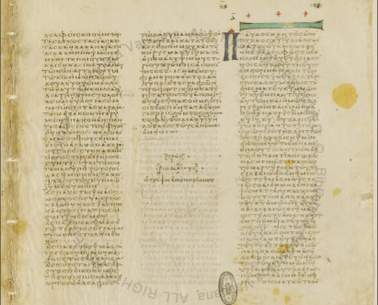
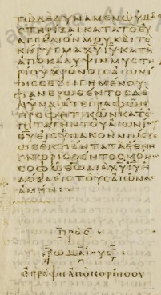
Where do Romans 16:25-27 belong?

Right where they are! (At the end of Romans 16)
P⁶¹ – ca. 700, Pauline letters
א (Sinaiticus) – 4th cent., pandect Bible
B (Vaticanus) – 4th cent., pandect Bible
C (Ephraemi Rescriptus) – 5th, pandect
D (Claromontanus) – 6th cent., Pauline

At the end of Ch. 14 and Ch. 16
A (Alexandrinus) – 5th cent., pandect
33 – 9th cent., Gospels, Acts, and Paul

Only at the end of Ch. 14
L – 9th cent., Acts and Paul
Ψ – 9th/10th, Gospels, Acts, and Paul

At the end of Ch. 15
P⁴⁶ – ca. 200, earliest surviving copy of Paul’s letters

Completely Omitted
F – 9th cent., Paul’s letters
G – 9th cent., Paul’s letters
